Challenge Number: 1009
Played on date: March 6, 2022 Time: 11:30
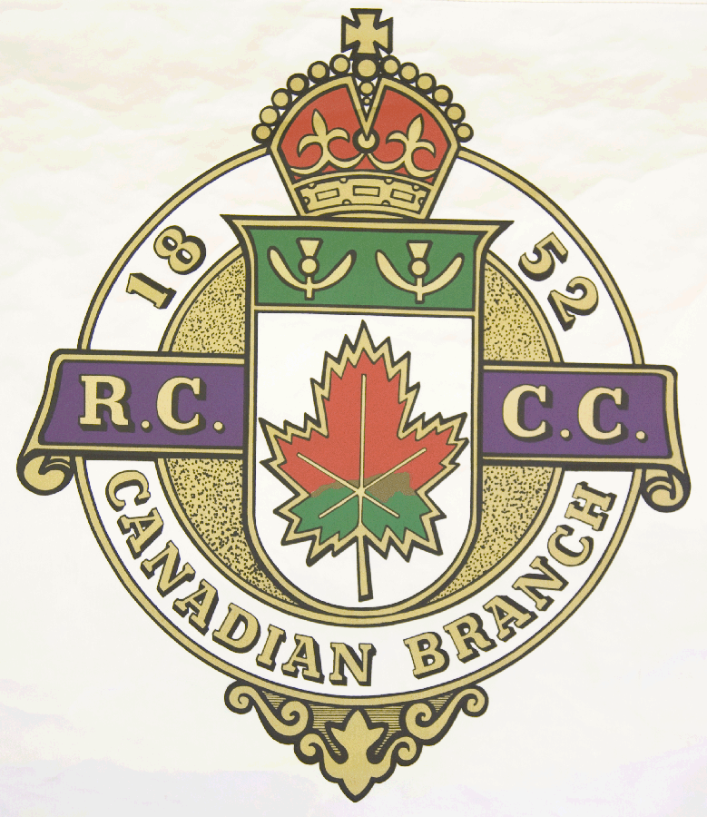
Hosting Club: Metcalfe Curling Club

Host Club Address: 2793 8th Line Road

Host Club City: Metcalfe, Ontario

Host Club Telephone: 613 - 821 - 2335

Host Contact Person: Bill Woods Sr.

Contact phone or email: bill.woods@sympatico.ca

Hosting Club: Metcalfe Challenging Club: Lacolle

Skip: WEW Woods Skip: Bob Gill

Third: Don Chasse Third: Owen MacCallum

Second: Eric Bradbury Second: Serge Guillette

Lead: Richard Tessier Lead: David Janigan

Skip: WJR Woods Skip: Éric Genest

Third: Bill Carr Third: Robert Boucher

Second: Hyo Min Lee Second: Jean-Pierre Maurice

Lead: Terry Lantz Lead: François Audette .

 | Skip | 1 | 2 | 3 | 4 | 5 | 6 | 7 | 8 | 9 | 10 | Score
Sheet | WEW Woods | 1 | 0 | 0 | 4 | 1 | 3 | 0 | 0 | 2 | 1 | 12
Sheet | Bob Gill | 0 | 2 | 1 | 0 | 0 | 0 | 1 | 1 | 0 | 0 | 5
Sheet | WJR Woods | 1 | 0 | 0 | 1 | 0 | 2 | 0 | 0 | 1 | 0 | 5
Sheet | Éric Genest | 0 | 1 | 1 | 0 | 1 | 0 | 3 | 2 | 0 | 1 | 9

Hosting club score: 17____ Challenging club score: __ 14____

